To find following the machines learning regression method using in r values.

1. Multiple Linear Regression (R-values = 0.9358680970046241)

2. Support Vector Machine

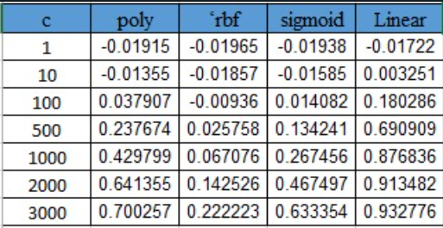

The SVM regression use R-values (Linear and Hyper parameter C=3000==0.932776)

3. Decision Tree

|  |  |  |  |
| --- | --- | --- | --- |
| Criterion | Max Features | Splitter | R-values |
| squared_error | sqrt | best | 0.8850731 |
|  | sqrt | random | 0.667377 |
|  | log2 | best | 0.404338 |
|  | log2 | random | 0.525066 |
|  | None | best | 0.7861781 |
|  | None | random | 0.7783116 |
| friedman_mse | sqrt | best | 0.8511950 |
|  | sqrt | random | 0.796298 |
|  | log2 | best | 0.711390 |
|  | log2 | random | 0.4065366 |
|  | None | best | 0.755583 |
|  | None | random | 0.8519220 |
| absolute error | sqrt | best | 0.665112 |
|  | sqrt | random | 0.728114 |
|  | log2 | best | 0.44184 |
|  | log2 | random | 0.7424603 |
|  | None | best | 0.882405 |
|  | None | random | 0.312174 |
| poisson | sqrt | best | 0.658386 |
|  | sqrt | random | 0.6125311 |
|  | log2 | best | 0.46443 |
|  | log2 | random | 0.54001 |
|  | None | best | 0.883268 |
|  | None | random | 0.873638 |

The Decision Tree use R-value is 0.8850731 for the ‘squared error ‘criterion with ‘sqrt’ and ‘best’.

4. Random Forest

|  |  |  |  |
| --- | --- | --- | --- |
| Criterion | Max Features | N_Estimators | R-values |
| squared_error | sqrt | 50 | 0.6830022 |
|  | sqrt | 100 | 0.75915 |
|  | log2 | 50 | 0.6830022 |
|  | log2 | 100 | 0.759150 |
|  | None | 50 | 0.94463 |
|  | None | 100 | 0.9460 |
| friedman_mse | sqrt | 50 | 0.688918 |
|  | sqrt | 100 | 0.7608592 |
|  | log2 | 50 | 0.688918 |
|  | log2 | 100 | 0.760859 |
|  | None | 50 | 0.9388957 |
|  | None | 100 | 0.94127 |
| absolute error | sqrt | 50 | 0.7222 |
|  | sqrt | 100 | 0.78574 |
|  | log2 | 50 | 0.72223 |
|  | log2 | 100 | 0.785748 |
|  | None | 50 | 0.940193 |
|  | None | 100 | 0.94590 |
| poisson | sqrt | 50 | 0.720862 |
|  | sqrt | 100 | 0.7717642 |
|  | log2 | 50 | 0.720862 |
|  | log2 | 100 | 0.771764 |
|  | None | 50 | 0.94635497 |
|  | None | 100 | 0.94138 |

The highest R-value is 0.94635497 for the poisson criterion with None as max_features and 50 as estimators.